Assignment 5
Name:-Yadnesh Patil
PRN:-123B1D034
Assignment 5 : SQL Grouping and databse views.
Database Schema (Banking System)
mysql> SHOW DATABASES;
mysql> CREATE DATABASE Banking_System_Assignment_5;
mysql> USE Banking_System_Assignment_5;
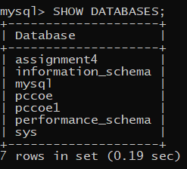
CREATE TABLES:
- Customers
mysql> CREATE TABLE Customers(customer_id INT PRIMARY KEY,name VARCHAR(50),dob DATE,city VARCHAR(50),account_type VARCHAR(50));
- Branches
mysql> CREATE TABLE Branches (branch_id INT PRIMARY KEY,branch_name VARCHAR(50),city VARCHAR(50));

- Loans
mysql> CREATE TABLE Loans (loan_id INT PRIMARY KEY,customer_id INT,amount DECIMAL(10, 2),loan_type VARCHAR(50),status VARCHAR(50),FOREIGN KEY (customer_id) REFERENCES Customers(customer_id));
- Accounts
mysql> CREATE TABLE Accounts (account_id INT PRIMARY KEY,customer_id INT,balance DECIMAL(10, 2),account_type VARCHAR(50),branch_id INT,FOREIGN KEY (customer_id) REFERENCES Customers(customer_id),FOREIGN KEY (branch_id) REFERENCES Branches(branch_id));
- Transactions
mysql> CREATE TABLE Transactions (transaction_id INT PRIMARY KEY,account_id INT,amount DECIMAL(10, 2),transaction_type VARCHAR(50),transaction_date DATE,FOREIGN KEY (account_id) REFERENCES Accounts(account_id));
INSERTING VALUES INTO TABLES
- Customers
mysql> INSERT INTO Customers (customer_id, name, dob, city, account_type) VALUES -> (67, 'Atharva', '2003-05-21', 'Pune', 'Savings'), -> (68, 'Virendra', '2002-08-12', 'Mumbai', 'Current'), -> (69, 'Prateek', '2000-01-15', 'Delhi', 'Savings'), -> (70, 'Vishwajeet', '1999-09-09', 'New York', 'Current'), -> (71, 'Onkar', '2001-06-30', 'Los Angeles', 'Savings'), -> (72, 'Aryan', '2003-03-03', 'Chicago', 'Current'), -> (73, 'Shruti', '2002-10-19', 'Pune', 'Savings'), -> (74, 'Shashwati', '2001-07-25', 'Delhi', 'Current'), -> (75, 'Tanaya', '1998-11-07', 'New York', 'Savings');
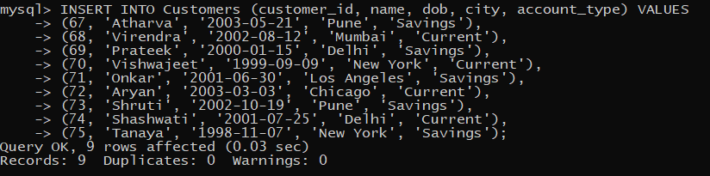

- Branches
mysql> INSERT INTO Branches (branch_id, branch_name, city) VALUES -> (1, 'Shivajinagar Branch', 'Pune'), -> (2, 'Fort Branch', 'Mumbai'), -> (3, 'Connaught Place Branch', 'Delhi'), -> (4, 'East Side Branch', 'New York'), -> (5, 'Santa Monica Branch', 'Los Angeles'); 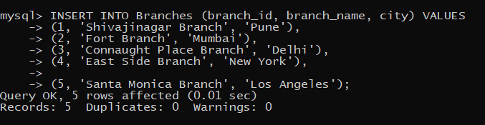
- Accounts
mysql> INSERT INTO Accounts (account_id, customer_id, balance, account_type, branch_id) VALUES
-> (101, 67, 45000.00, 'Savings', 1), -> (102, 68, 30000.00, 'Current', 2), -> (103, 69, 60000.00, 'Savings', 3), -> (104, 70, 80000.00, 'Current', 4), -> (105, 71, 20000.00, 'Savings', 5), -> (106, 72, 55000.00, 'Current', 5), -> (107, 73, 75000.00, 'Savings', 1), -> (108, 74, 120000.00, 'Current', 3), -> (109, 75, 15000.00, 'Savings', 4);
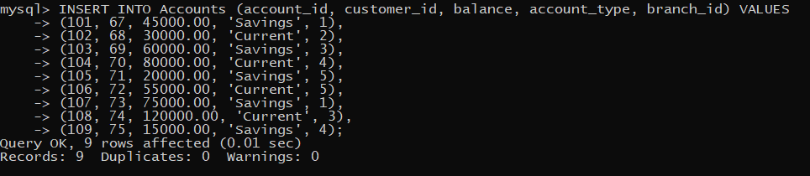
- Transactions
mysql> INSERT INTO Transactions (transaction_id, account_id, amount, transaction_type, transaction_date) VALUES
-> (201, 101, 5000.00, 'Deposit', '2024-01-10'),
-> (202, 102, 3000.00, 'Withdrawal', '2024-01-15'),
-> (203, 103, 10000.00, 'Deposit', '2023-11-20'),
-> (204, 104, 2000.00, 'Transfer', '2024-01-25'),
-> (205, 105, 4000.00, 'Withdrawal', '2023-12-05'),
-> (206, 106, 6000.00, 'Deposit', '2024-02-01'),
-> (207, 107, 8000.00, 'Withdrawal', '2023-11-25'),
-> (208, 108, 3000.00, 'Deposit', '2024-02-05'),
-> (209, 109, 2000.00, 'Withdrawal', '2023-12-15');
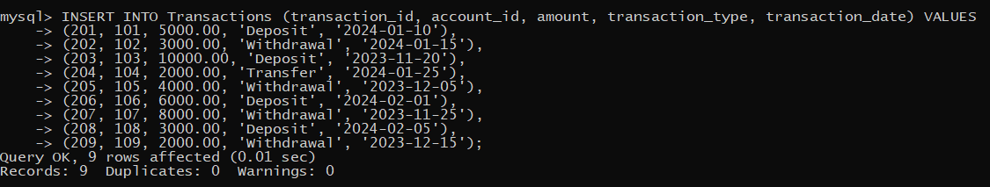
- Loans
mysql> INSERT INTO Loans (loan_id, customer_id, amount, loan_type, status) VALUES -> (301, 67, 200000.00, 'Home', 'Approved'), -> (302, 69, 100000.00, 'Car', 'Pending'), -> (303, 71, 50000.00, 'Personal', 'Approved'), -> (304, 74, 150000.00, 'Home', 'Rejected'), -> (305, 75, 80000.00, 'Car', 'Approved');
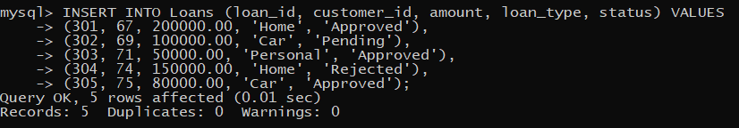

DISPLAYING TABLES
- Customers
mysql> SELECT * FROM Customers;
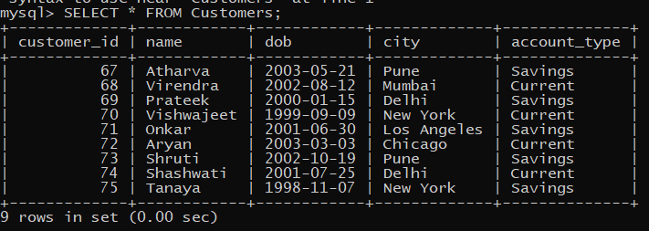

- Branches
mysql> SELECT * FROM Branches;
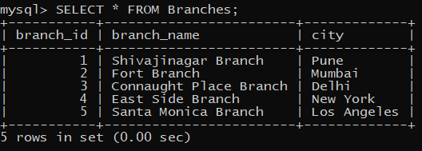
- Accounts
mysql> SELECT * FROM Accounts;
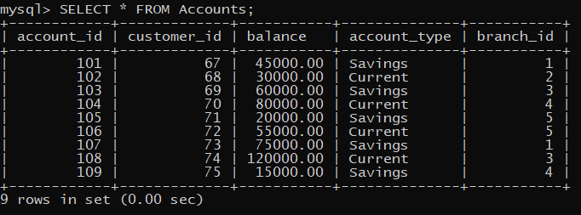
- Transactions
mysql> SELECT * FROM Transactions;
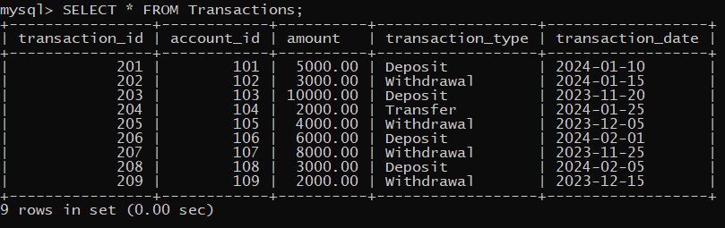
- Loans
mysql> SELECT * FROM Loans;
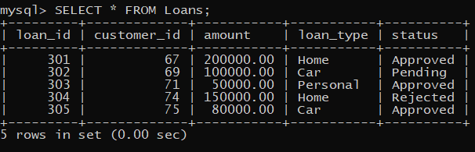
Solve following queries :
1). Retrieve the total balance for each account type.
mysql> SELECT account_type, SUM(balance) AS total_balance FROM Accounts GROUP BY account_type;
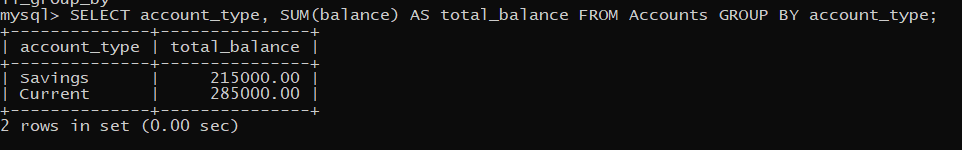
2). Count the number of accounts in each branch.
mysql> SELECT branch_id, COUNT(*) AS account_count FROM Accounts GROUP BY branch_id;
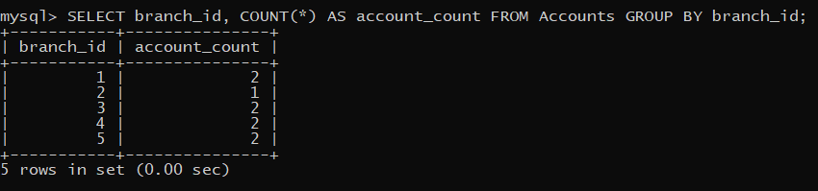
3). Find the number of customers in each city.
mysql> SELECT city, COUNT(*) AS customer_count FROM Customers GROUP BY city;
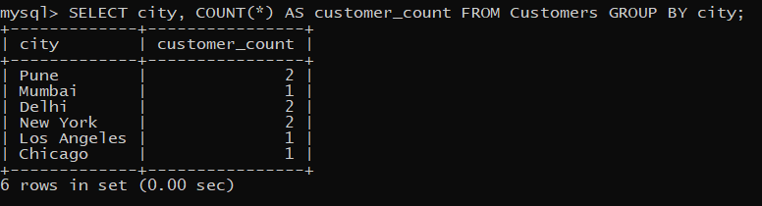

4). Show the number of loans approved per loan type.
mysql> SELECT loan_type, COUNT(*) AS approved_loans FROM Loans WHERE status = 'Approved' GROUP BY loan_type;
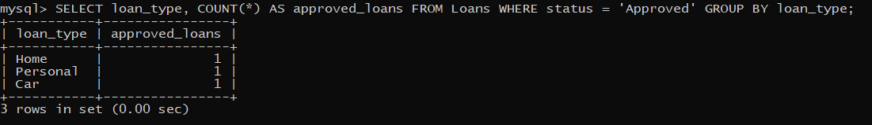

5). Find the total number of transactions for each transaction type.
mysql> SELECT transaction_type, COUNT(*) AS transaction_count FROM Transactions GROUP BY transaction_type;
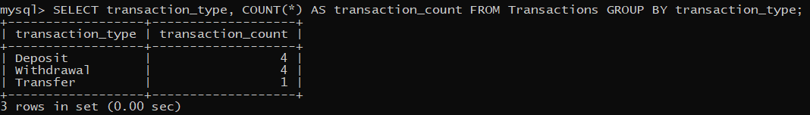

6). Show the customers who do not have a loan.
mysql> SELECT * FROM Customers WHERE customer_id NOT IN (SELECT customer_id FROM Loans);
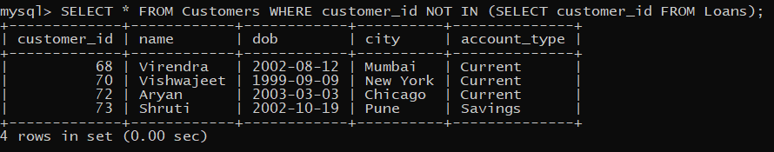

7). Retrieve customers who have accounts in more than one branch.
mysql> SELECT branch_id, COUNT(*) AS TOTAL_ACCOUNTS FROM accounts GROUP BY branch_id;
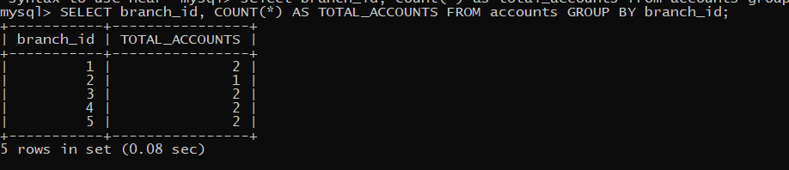

8). Find all accounts that have not had any deposits in the last 3 months.
mysql> SELECT * FROM Accounts WHERE account_id NOT IN (SELECT account_id FROM Transactions WHERE transaction_type = 'Deposit' AND transaction_date >= DATE_SUB(CURDATE(), INTERVAL 3 MONTH));

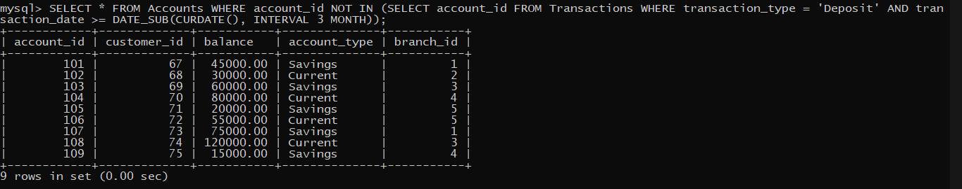

9). Display the account types where the total balance is below ₹25,000.
mysql> SELECT account_type, SUM(balance) AS total_balance FROM Accounts GROUP BY account_type HAVING SUM(balance) < 25000;

10). Find the total balance per account type where the balance is above ₹50,000.
mysql> SELECT account_type, SUM(balance) AS total_balance FROM Accounts WHERE balance > 50000 GROUP BY account_type;
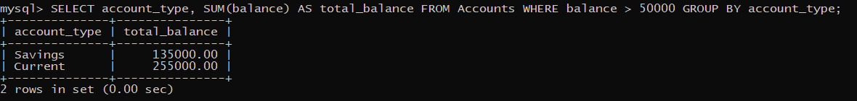

11). Retrieve the count of transactions made on dates where more than 5 transactions
occurred.
mysql> SELECT COUNT(DISTINCT transaction_date) FROM Transactions GROUP BY transaction_date HAVING COUNT(*) > 5;

12). Find the top 3 transaction days with the highest total transaction amount.
mysql> SELECT transaction_date, SUM(amount) AS total_amount FROM Transactions GROUP BY transaction_date ORDER BY total_amount DESC LIMIT 3;
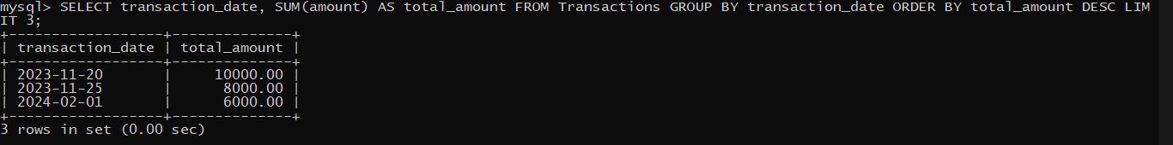

13). Find customers who have a loan but no account in the bank.
mysql> SELECT l.customer_id FROM loans l LEFT JOIN accounts a ON l.customer_id = a.customer_id WHERE a.customer_id IS NULL;

